Friday Quiz 15th May 2026
- Who is in Vienna tomorrow proclaiming their lack of technology to their family? The UK’s entrant in Eurovision – Sam Battle aka Look Mum, No Computer.
- The Prime Minister of which European country resigned this week? Latvia
- Complete the film quote with the name of the film: “If we could somehow harness this bolt of lightning, channel it into the flux capacitor, it just might work.
Next Saturday night, we're sending you _____ __ ___ ______” Back to the Future
- Who is this?  Brad Pitt
- Which country has the most cows, over 200 million? Brazil
- Which top flight European soccer club shares its name with a hero from Greek mythology? Ajax
- How many planets can be seen without a telescope (not counting Earth)? I’ll accept 5 or 6. Accepted wisdom is 5, but Uranus can also dimly be seen
- What did Peter the Great tax in order to encourage Russians to become more Western? Beards
- What links the pictures?.  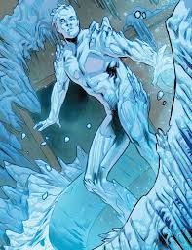 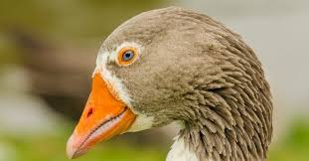 Call signs from Top Gun – Maverick; Ice Man; Goose

- Which UK city is this?  Edinburgh

- What ‘T’ is the classification of plants and animals into species, genus etc? Taxonomy
- Name the discontinued chocolate bar  Mars Delight
- What disease first emerged in 2002, with the largest outbreak happening in Hong Kong? SARS
- Which artist walked a pet giant anteater around Paris on a lead as a publicity stunt? Salvador Dali
- What 4-letter word is a fortified tower within a castle? Keep
- Change the first letter of a Eurovision winner to find a teatime treat . Give both words. Loreen & Soreen
- Name the film  I Swear
- Monique writes down a list of five numbers. The mean (average) of her first three numbers is −3. The mean of her first four numbers is 4. The mean of her first five numbers is −5. What is the difference between her fourth number and her fifth number? 66. From the given information, the sum of Monique’s first three numbers is −9, the sum of her first four numbers is 16, and the sum of her first five numbers is −25. Therefore the fourth number is 16 − (−9) = 25, and the fifth number is −25 − 16 = −41. The difference between them is 25 − (−41) = 66

- What links the pictures? Robert de Niro films: Awakenings; Brazil; Taxi Driver; Raging Bull; King of Comedy.

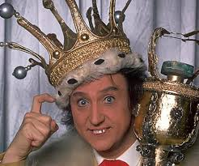

- Unscramble the two words: A A E H I I N N O O P R X Z PHOENIX & ARIZONA

